
A report on the state of the mobile voter registration process
29 April to 06 May 2013
_______________________________________________________________________________________
- Introduction

The Election Resource Centre (ERC) commends government efforts aimed at enfranchising the majority of Zimbabweans as the nation approaches crucial elections in 2013. With nine days after the state supported decentralization of voter and civil registration started, the ERC has however observed some administrative anomalies which have the potential to undermine the otherwise necessary process of registering prospective voters.
Whilst the process is continuing in some of the areas, the outreach is evidently yet to be witnessed in most electoral districts. In places which the mobile registration teams have visited a number of potential voters remain disenfranchised due to a myriad of challenges ranging from lack of publicity, inadequate time allocation, the cost of registration, limited civil registration services and difficulties in acquiring necessary documents like proof of residence. The foregoing challenges have the inevitable effect of excluding a significant number of eligible voters from the imminent general elections.
The process has also been affected by reports that there is disproportionate distribution of the mobile voter registration teams throughout the country’s provinces, with observations that some provinces, with a high contribution to the national population have fewer mobile registration centres. Yet some with a low contribution to the national population have a high number of centres.
The ERC therefore calls upon the electoral authorities to immediately attend to the emerging challenges in order to enable all interested eligible voters to either register as such or inspect details of their registration in the country`s voter register.
The ERC is monitoring the mobile voter registration (MVR) process which started on the 29th of April 2013 and initially expected to finish on the 19th of May 2013. Through its volunteer networks and X1G (first time voters) mobile caravans, which are monitoring and complementing the process as well as providing information to the young people on the process throughout the country’s ten provinces, the ERC is able to gather reports around the ongoing voter process.

- Guiding Principles for Voter Registration

PRINCIPLE | EXPLANATION
Integrity | Voter registration framework and processes must be fair and honest, free from political and other manipulation or intimidation, allow all eligible person to register as voters and not allow ineligible persons to register as voters
Inclusiveness | Voter registration frameworks and processes should not contain measures that exclude persons from registration to serve political advantage. For example, there should be no:  • criteria for eligibility to register;  • differentiation in resources provided for registration processes;  • differentiation in accessibility;  • differentiation in assurances for security or safety; or  • imposition of additional checks or administrative obstacles that may deny one the opportunity to register to vote, or make it more difficult to register to vote for persons assumed to have a certain political tendency.
Comprehensiveness | Voter registration exercises should aim at registering 100% of qualified persons, including those societal groups that may be less inclined to register to vote, such as women, youth and those to whom standard registration processes may be less accessible.
Accuracy | All voter registration information should be recorded accurately and maintained properly so that the voter lists used for elections are up to date. This may require implementing systems to check data validity and the accuracy of data recording, as well as proactive programmes to check that all data is up to date and to receive advice of and process any necessary amendments.
Accessibility | Voter registration processes should be physically and geographically accessible as well as readily understandable by all persons qualified to register. Any locations used for voter registration purposes and which require the public to attend to provide or check information should be:  • physically accessible to all – including the elderly and disabled;  • open at times that can service all employed, unemployed and rural farm populations;  • readily accessible on foot or serviced by regular public transport, and located within reasonable distance of all eligible voters in its catchment area – using mobile locations in more sparsely populated areas may assist in this; and  • At a place that does not intimidate potential voters. For example, locating voter registration centres near offices associated with the ruling party, or law enforcement/military agencies may in some instances deter people from attending.
An informed public | Voter registration processes should be clearly explained and widely publicised to all potential eligible voters as well as to all stakeholder organisations in the electoral process, such as political parties, the media and CSOs.
Transparency | Transparency in registering voters promotes public trust in the integrity of voter registration processes and products. Civil society, particularly through professional and impartial monitoring and reporting by CSOs, and fair investigation and reporting by the media can enhance the transparency of voter registration.
Security | Field registration staff and people registering to vote must be assured of their safety and security. Voters must be able to trust that registering to vote will not result in their being subjected to consequent discrimination, intimidation or violence. Registration staff must be supervised and protected against any action by outside persons so that they can conduct their work in an honest, professional and impartial manner. Voter registration information stored in both paper and electronic formats must be sufficiently secure to prevent unauthorised access, to protect against unauthorised alteration or disclosure and to ensure that any legal requirements for information privacy are met.
Information Privacy | In some countries information privacy is legislated and protected by law. If not, privacy rights should be included in the framework for voter registration. Information provided by people directly for the voter registration process should not be available to any government or private organisation that can use this information for purposes which could deter people from registering to vote. The purpose of voter registration is to allow citizens to exercise their basic political right to vote; it is not an information gathering exercise to be shared with other institutions, such as law enforcement authorities or for commercial interests.
Accountability | The institution(s) responsible for voter registration must be subject to accountability mechanisms which ensure that the objectives of voter registration are achieved and that the principles of voter registration have been applied. These mechanisms could be internal (such as internal reviews and audits of the voter registration system, process and data) or external. External accountability mechanisms for voter registration that could be applied include:  • a process for public review of the voters’ roll;  • rights of the public in general and stakeholders in particular to lodge administrative challenges to errors, omissions and inclusions in the voters’ roll;  • independent external audits and evaluations;  • rights of affected parties to lodge judicial appeals against decisions made by administrative bodies in relation to the voters’ roll;  • access for political party and independent observers to observe all voter registration processes, their right to lodge complaints about any irregularities and to have these resolved effectively; and  • public reporting and reporting to parliament by the EMB on the  extent to which it has met its voter registration objectives
Credibility | Political parties and the public need to believe that voter registration has been conducted with integrity, equity, accuracy and effectiveness. Transparency measures and the provision of regular and accurate information on voter registration can promote public credibility in a well-implemented registration process, and can also provide knowledge to improve less well-implemented processes.
Stakeholder Participation | Stakeholders must be informed regularly and their views considered both at the decision-making phase and during the conduct of a voter registration exercise. This will increase stakeholders’ support and trust of the overall process and its product – the voters’ roll. Primary stakeholders are directly affected by the voter registration process or its outcome. Included in this category are citizens who are eligible to register, the registration authority, political parties and candidates, executive government, legislatures, EMB staff, contractors, electoral dispute resolution and supervisory bodies, the media, observers and monitors, CSOs, donors and assistance agencies, and suppliers and vendors. Secondary stakeholders have an interest but are not directly affected by the exercise. Included in this category are the general public, academia, international or regional electoral networks and research institutes.

- KEY FINDINGS

Based on the above principles, the ERC has made a preliminary assessment of the first seven days of the mobile voter registration process. The findings are as follows;
- Some registration centres opened late
The general situation is that fewer registration teams were deployed on Monday 29 April, with the majority of districts reportedly starting on days later that the official date.
- Lack of publicity
The mobile registration process is lacking in awareness and publicity around when and where the registration process is to take place. Whilst there are reported cases of prior notification through selected traditional leaders, such voter awareness was often devoid of the intricate details relating to what type of services are being rendered by the mobile teams. This has resulted in a number of potential voters being turned away because they would have visited the centres seeking to recover their lost birth certificates as well, a service which is not being offered by the mobile registration teams. The lack of sufficient information drive and publicity around the process means that the process has the potential of being shadowy to potential voters intending to register as voters. The potential registrants will not be able to register because of a lack of information on the whole process.

- Inadequate time
Most centres were only opened for a shorter period thereby failing to meet demand of citizens visiting the centres. Due to mentioned lack of publicity, people take time to know of the presence of the mobile teams, by the time they get to know of their presence, the mobile teams would have moved to another designated centre, a distance away. Some registration centres are serving more than 3 wards, which is leaving the teams overwhelmed as they will not be able to service all interested people intending to register as voters.

- Non-Compliance

Some key government institutions, that are supposed to be complementing and aiding the mobile voter registration teams, seem to be unaware of their responsibilities and roles. We have received reports that for instance, the police in some areas are not issuing out police reports to potential first time voter registrants that facilitates one to get an ID for free. It seems the police are not aware of this government directive as reports of police in some areas refusing/not issuing out police reports to those who need them are being received.
- Lack of Full services
It has been observed that the mobile voter registration teams are not providing some services which are important for one to register. For instance, the teams are not issuing out birth certificates which are a requisite for one to obtain an ID, itself a requirement for one to register as a voter.

- Presentation of Population Statistics and Voter Population
This section makes chart presentations of the population statistics in the country as of August 2012, taken from the 2012 population census. We show the variables of provincial population and the provincial voter population as of 2008, which variables can be indicative and important in analysing the implementation of the mobile voter registration exercise
The pie chart illustrates the provincial population according to the August 2012 census

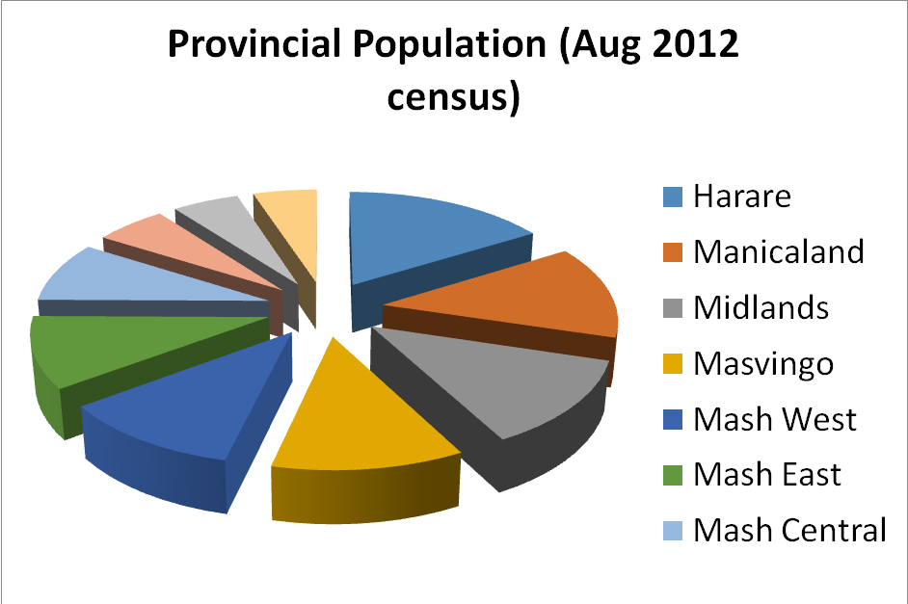

The graph illustrates the total voter population as of 2008, by province.

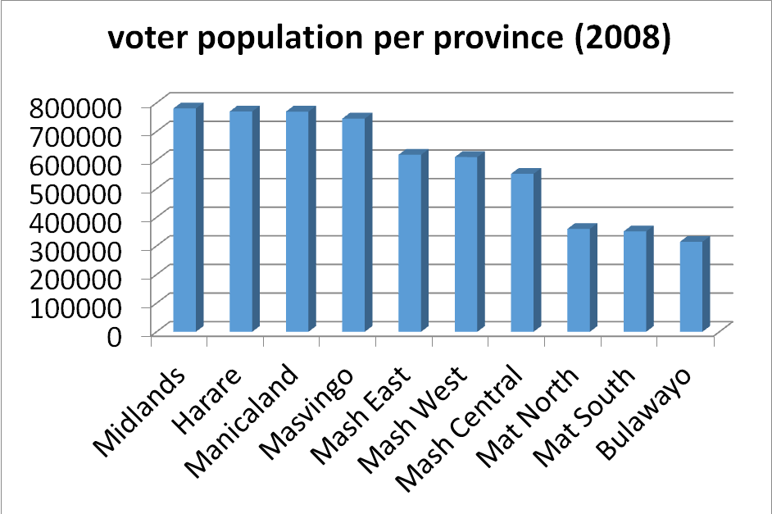

- Analysis of Registration Centres/Census Results/Voter Population
On the 4th of May 2013, ZEC published a list of places, dates and areas to which the mobile registration teams would visit. Such publication was finally done about six days after the mobile registration exercise had started, which meant that the citizens were blacked on such crucial information and could have prevented many people who wanted to register from doing the same.
The table below shows the province, number of constituencies in that province, and the number of centres in the province. We also highlight the total population in each province as of August 18 2012 (Census Results) and the total voter population per province as of 2008.

PROVINCE | CONSTITUENCIES | CENTRES | Total Census Population | Total Voter Population (2010)
Harare | 29 | 18 | 2 098 199 (16.2%) | 770 080
Manicaland | 26 | 49 | 1 755 000 (13.5%) | 769 621
Mash Central | 18 | 76 | 1 139 940 (8.8%) | 552 211
Mash West | 22 | 77 | 1 449 938 (11%) | 610 703
Masvingo | 26 | 43 | 1 486 604 (11%) | 745 124
Mash East | 22 | 100 | 1 337 059 (10.3%) | 618 653
Bulawayo | 12 | 12 | 655 675 (5%) | 314 508
Mat North | 13 | 89 | 743 871 (5.7%) | 359 606
Mat South | 13 | 85 | 685 046 (5.3%) | 350 897
Midlands | 28 | 74 | 1 622 476 (13.5%) | 780646

- Findings on registration centres

- Disproportionate distribution of mobile registration teams –Some provinces which according to the Census figures, have a high contribution to the national population, have been allocated fewer mobile voter registration centres. In comparison, some provinces which have a low contribution to the national population have high allocation of centres
- Urban Skirting-Most urban areas like Mutare, Chipinge, Gwanda and Masvingo have no designated registration centres
- Leave voting, go to school-No registration centres in areas with a high concentration of youths like colleges and universities. This has greatly affected areas like Mt Pleasant and Senga in Gweru.
- Deception-Some centres were not opened as per published schedule

- RECOMMENDATIONS

- Decentralization must reach at least the polling station level in order to lessen the travelling distance as well as enable the elderly and disabled to have easier access to voter registration services.
- Mobile teams must provide full services to potential voters as opposed to limiting the decentralized services to IDs and voter registration only, without providing birth certificates.
- Voter education and publicity must precede the mobile registration teams
- Requirements such as proof of residence need to be reviewed, especially for urban voters and young voters who find it difficult to produce proof of residence e.g. in Harare South, there is a concentration of informal settlements and are not able to get proof of residence
- ZEC should consider increasing mobile voter registration teams in areas with a higher population density to avoid disenfranchisement of citizens intending to register as voters but are not able due to constraints and lack of access.

Contact//
Election Resource Centre
Email: erczimbabwe@gmail.com
Facebook: @Election Resource Centre Zimbabwe
Twitter/Skype: @erczimbabwe
Website: www.erc.org.zw
Phone: 0776347629

Refer to Voter Registration in Africa: A Comparative Analysis, edited by Astrid Evrensel

